AI Colors

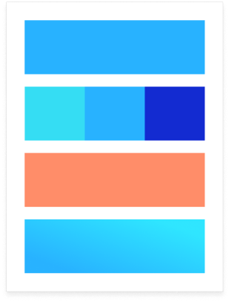

# Primary

#28B2FF

# Secondaries

#35DDF3

#28B2FF

#132BD1

# Accent

#FF8D69

# Gradient

#2FE6FF to #28B2FF